**Valeo Innovation Challenge**

**Phase 2 Technical file**

To be uploaded as a .pdf document to the Valeo Innovation Challenge website

before the submission deadline

**Deadline: August, 29th 2014; 8:00 pm CET**

|  |
| --- |
| *Please remember the* ***Valeo Innovation Challenge Rules and the FAQ*** *before starting the description of your proposal. Bear in mind that the proposal will be evaluated according to the selection criteria set out in the rules Article 6.*  *The technical file* ***must respect this template using the******headings*** *on page 2. The structure of this document and the font must not be changed. The* ***minimum font size*** *allowed is* ***11*** *points and the font type is* ***Arial****. The maximum number of* ***20 pages*** *should be respected. You can insert texts, images or drawings.* |

**Team name**: Nikola Motors

**Project title**: Powering Automobiles through Wireless Power Transmission

**Abstract (15 lines max)**:

Current automobile propulsion systems are not sustainable. They are harmful to the environment, expensive and inconvenient to  the driver. Battery-powered electric vehicles (BEVs) are a promising alternative to internal combustion-powered vehicles, but they have several drawbacks which also prevent them from becoming widely used in their current state. Our system eliminates many of these drawbacks by using wireless power transmission (WPT)  to power an electric vehicle, decreasing fueling costs, increasing vehicle efficiency, decreasing greenhouse gas pollution, and improving the overall convenience of the electric vehicle. This system includes a series of high-directivity transmitters which are placed above the road and transmit power in the form of radio waves directed onto the surface of the road. The transmitted power is captured by rectennas which are mounted to the exterior of each vehicle and convert it to direct current so that it can be used to charge the vehicle’s battery and propel the vehicle. Vehicles utilizing this WPT technology are outfitted with Radio Frequency Identification (RFID) tags which are detected by RFID readers on the transmitters, activating the transmitter systems. The RFID detection system ensures that no energy is wasted while WPT vehicles are not passing in the transmitter system range. The vehicle’s auxiliary battery stores unused energy and ensures that the vehicle can continue to travel for up to thirty kilometers without receiving any power transmission. An electronic control unit distributes power from the motor to the rest of the vehicle. A physical scaled-down mock-up was built to model the proposed WPT transmitter and vehicle. Testing showed unfavorable results with the problem localized to the power transmission system.

|  |  |
| --- | --- |
| **Questions** | *Indicative nb of pages* |
| **1: What is the problem? Or situation to improve?**   * What are the expected impacts-benefits if improved / corrected? * Speak with data as far as possible. | *1-2* |
| **2: What is/are the current solution(s) / state of the art?**   * What are the remaining challenges to solve (technical, economic, societal, etc…)? | *2-4* |
| **3: What is your solution?**   * Describe selected concepts, principles, and technologies. * Give detailed technical information (architecture, hardware, software, etc.). * Illustrate with figures / data / schematics / drawings as far as possible. | *4-7* |
| **4: Present your mock’ up**.   * Be it simulation, physical mock-up with evaluation/tests, animation, video, etc. * Describe/show how it works, how it is built. * What are the associated characteristics / performances / limits (can do/cannot do)? * Identify the difficult points / issues to be solved (technical challenges to implement it in the coming years) * Describe the improvements to be brought during further developments. | *4-7* |
| **5: If you belong to the Top 6 finalists**.   * How do you plan to present your Innovation to the Grand Jury in Paris (20' presentation on stage - materials requested? / transport of the mock up requirements?) | *0,5* |

**The Problem and Current Solutions**

The problem with current automobiles is that the power sources driving the vehicles are not sustainable. They can be improved to decrease vehicle costs and negative environmental effects while providing the driver with an overall better experience. Current power sources contribute heavily to pollution, are expensive, and inconvenience the driver.

The current vehicle design is essentially four wheels powered by either an internal combustion (IC) engine or electric motor and battery. The first is fossil fuel dependent. In this sense, the IC engine is unsustainable and will only be functional for as long as fossil fuels remain a viable commodity. In the United States, oil is expected to be available for less than 12 more years [1]. The US will then become entirely dependent on outside sources for IC engine fuel, and these sources also will soon become depleted. With a supply expected to last more than 100 years, Iraq and Kuwait are among those countries with the greatest amount of oil left, but as recent news can attest, both are located in an unstable environment [1]. Political changes and war that plague the Middle East can impede access to these supplies. At the same time, war and other unexpected incidents may increase the demand for this fuel and deplete the remaining fuel more quickly than anticipated. Additionally, burning fuel in an IC engine releases harmful greenhouse gases (GHGs) into the atmosphere. According to Dr. Hare of the Potsdam Institute for Climate Impact Research, an increase in the overall level of GHGs in the atmosphere is leading to global temperature increase and climate change [2]. Dr. Hare postulates that if global temperature increase is not limited to 1 deg. C, then we will face damaging climate change effects, mass extinction of vulnerable species, and possibly severe and rapid temperature increase [2]. Dr. Hare advises that net greenhouse gas (GHG) emissions be reduced to zero by 2050 and negative levels of GHGs be emitted from that point on in order to begin to reverse the harmful effects of climate change [2]. With the continued use of IC-powered vehicles, this will be impossible. According to the Environmental Protection Agency (EPA), vehicles emitted approximately 1.5 gigatons of CO2, a GHG, in 2009 and accounted for 4% of the world’s total GHG emissions [3]. 4% may seem insignificant, but as one can see depicted in Figure 1, over 50% of average American household’s GHG emissions were produced by their vehicles [3]. Currently, there are one billion vehicles registered worldwide, and this number is predicted to double within 20 years as vehicles become more affordable and standards of living improve in developing nations across the world [4]. Therefore, decreasing the a

mount of GHGs emitted by automobiles is a critical improvement to the current automobile design.

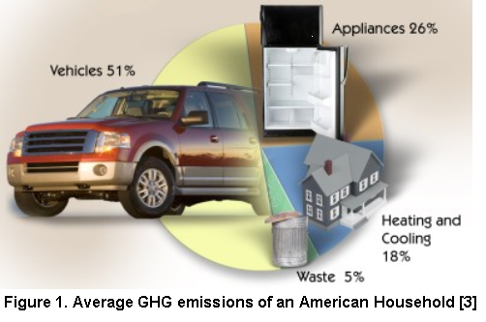What’s more, according to the Canadian Association of Petroleum Producers and the EPA, 55 megatons of GHG emissions result from the production, refinement, transportation and storage of crude oil [5,6]. These emissions make up approximately 30% of the total oil-related emissions and consist primarily of methane (CH4). According to the EPA, the impact of CH4 on climate change is 20% greater than that of CO2 when compared pound to pound. This further proves that eliminating automobiles’ dependence on oil for power is an important improvement for the wellbeing of the world.

The second vehicle propulsion system currently in production, the electric motor/battery, eliminates all GHG emissions produced directly by vehicles by using energy stored in batteries to drive an electric motor and power the vehicle. Once the battery is drained, this battery-powered electric vehicle (BEV) is charged by plugging the vehicle into the power grid; while it is a promising alternative to IC propulsion, the BEV is not completely clean. One problem is the size of the batteries that power the BEV. The popular Tesla Model S’s battery weighs approximately 1/3 the total weight of the vehicle, accounting for 900 pounds of the total 2700 pound weight of the vehicle [7]. This added weight increases the amount of energy needed to power the vehicle, forcing the vehicle to draw additional power from the power grid. Efforts are being made around the world to harvest renewable energy sources to power the grids, but in many cases, the availability of non-renewable energy sources and power plants which burn fossil fuels decrease the appeal of investing in renewable energy sources. For instance, according to the BP statistical review of world energy, Brazil and Pakistan are projected to have enough coal to power their countries for over 500 years, and Russia and the Ukraine have sufficient supplies of coal to last for 495 and 462 years, respectively [1]. With imminent political conflicts occurring in these countries, the citizens are unlikely to care about changing to more eco-friendly energy sources, when fossil fuel energy is readily available to them. In addition, power plants have large capital costs, for example between $3,000/kW and $6,000/kW for a solar photovoltaic plant [8]. Many countries have pressing political concerns that require large amounts of money and make footing the initial renewable power plant costs inconceivable. For all of these reasons, most nations are much more likely to provide energy to their country’s power grid through nonrenewable sources. The fact that most nations receive the majority of their power through the burning of fossil fuels further demonstrates how the added weight of the BEV battery becomes an issue demanding attention. Reducing the size of the batteries which power BEVs will cause a sizable decrease in the amount of GHGs emitted by the vehicles, and therefore is a major area in which the BEV could be made to be more viable.

The BEV battery, while releasing harmful GHGs into the air via the energy it receives from the power grid, also is manufactured with metals including cadmium, lead, mercury, copper, zinc, manganese, lithium, and potassium, which are all hazardous to the environment and also to human health in significant amounts [9]. During the manufacturing of these materials into batteries, GHGs, in particular sulfur hexafluoride (SF6), are produced [10]. SF6 is approximately 20,000 times more harmful to the environment than CO2 [10]. Lead, cadmium, and mercury are toxic to humans and damage the environment, although mercury’s use in batteries has declined greatly due to laws and regulations that have been put in place (e.g. US Battery Act, 1996) to reduce the mercury content in most batteries. Moreover, cadmium is easily taken up by plant roots and accumulates in fruits, vegetables and grass. The impure water and plants in turn are consumed by animals and human beings, who then fall prey to a host of ill-effects. Studies indicate that nausea, excessive salivation, abdominal pain, liver and kidney damage, skin irritation, headaches, asthma, nervousness, decreased IQ in children and sometimes even cancer can result from exposure to such metals for a prolonged period of time [9].Thus, proper disposal of batteries is extremely important in the eyes of battery manufacturers and recycling organizations. Unfortunately, the most widely used method of disposal is to send them to landfills, which is not an environmental friendly option. These harmful substances permeate into the soil, groundwater and surface water through landfills and also release toxins into the air when they are burnt in municipal waste gardens. Thus, decreasing the need for large batteries in vehicles is an appealing way to engineer a more environmentally friendly and safer vehicle.

While one can see that both IC vehicles and BEVs negatively impact the environment, these vehicles also have a major impact on a person’s wallet.  The IC engine is dependent on gasoline refined from oil for fuel; as gasoline availability decreases or is predicted to decrease the price increases. This occurred during the 1979 energy crisis. The Iranian Revolution caused a decrease in oil production, and oil production was nearly stopped at the outbreak of the Iran-Iraq War. While the oil supply worldwide decreased only ~4%, speculation predicting an even greater decrease in the supply of fuel caused a panic which increased the price of fuel significantly. The effects of this fluctuation on the American lifestyle can be seen looking back even further to the first oil crisis during 1973. During this time, the Organization of Arab Petroleum Exporting Countries (now OPEC) began an oil embargo lasting approximately a year [11]. The supply of fuel decreased drastically and caused an equally drastic increase in oil prices. A nationwide speed limit was affected, specific fueling days were installed, and Daytona 500 races were shortened, all in an effort to maintain fuel supplies [11]. The oil shock caused industry to suffer, and in less than one year, 45% of the value shown in the Dow Jones Industrial Average was lost [11].The volatility of the price of oil affects the American lifestyle in many ways. According to the Environmental Impact Assessment, U.S. Primary Energy Consumption by Source and Sector, 2004, 96% of transportation, 43% of industrial product, 21% of residential and commercial, and 3% of electric power are oil reliant [12]. Therefore, an increase in oil price, while seemingly small, can have a large effect on the profit of many companies and the spending of the average American. The lesson to be learned from these past examples is that it is necessary for a thriving economy to disentangle the automobile from its reliance on fossil fuels.

BEVs, on the other hand, are not subject to the price fluctuations of oil. Instead, the main cost of the BEV is its rechargeable battery, averaging about half the retail cost of the car itself. Currently, it is estimated that batteries cost around $400 per kilowatt-hour to manufacture [13]. This results in a total cost of $34000 for the 85 kW-h, 300 mile range, pack in the Tesla Model S. Additionally, increasing the power that the battery can produce to increase electric vehicle range and performance while unfortunately increasing battery size and charging requirements, also increases price sometimes by more than $1000 [14].Although electric vehicle battery cost has been reduced by more than 35% since 2008, consumers of the BEV market still consider costs to high [14]. According to Kamman et al in 2008, in order for BEV batteries to become more cost efficient, battery prices would have to decrease from about $1300/kWh to about $500/kWh [14]. Thus, allowing the battery to be able to pay for itself.

The battery requires a full charge as well. When the price of oil rises, the price of natural gas has been shown to follow suit, and again according to the U.S Primary Energy Consumption by Source and Sector 2004, natural gas fuels 14% of electric power, 73% of residential and commercial, and 39% of industrial production, electric power being what the BEV requires to recharge [11]. In this sense, the BEV is also subject to fluctuating oil prices in addition to the cost of battery manufacture. A smaller battery would require less charge to refuel and become less dependent on the given charging station. Vehicles can be improved to not require such an large, powerful battery.

The final improvements that could be made to the current vehicle designs would decrease the inconvenience to the driver. In the IC engine vehicle, the biggest inconvenience would be subjecting the driver to varying fuel availability and costs. Reducing the vehicle’s reliance on gasoline would reduce the amount of a person’s pay that would have to be used on his transportation vehicle versus supporting his and his possible family’s lifestyle.

The BEV also inconveniences the driver with the large price of its battery. Reducing the vehicles need for such a large battery would allow for a decrease in the vehicles price. The large battery inconveniences the driver in other ways. It adds excessive weight to the vehicle design which reduces its handling ability and decreases the quality of the driving experience. BEVs typically take multiple hours to fully charge their large battery. Decreasing the vehicles need for a large battery to travel long distances would decrease the size of the battery needed leading to a decreased charging time as well.

Currently though, range anxiety, or fear that one’s vehicle will have insufficient range to reach the desired destination, is a major barrier in the conversion to an all-electric car society. The average all-combustion vehicle has a range of about 500 kilometers or 310 miles while the average electric vehicle can travel anywhere between 80 - 120 miles before requiring a fill up [15]. Developing a battery that can succeed the range of a combustion vehicle on a single charge is very feasible. However development of such a battery is likely to increase the battery size. One way to increase BEV range aside from improving the battery, would be to increase the spread of available charging stations. According to Navigant Research, there are an estimated 64,000 electric vehicle charging stations worldwide and this is expected to increase to near 200,000 by 2020 [16]. This statistic is promising until one considers the spread of these stations and their funding source. Currently, the stations are localized mostly to the US, followed by China and Europe [17]. Therefore, while decreasing battery size and maintaining the ability to travel long distances in these regions may be feasible, other largely populated regions also dependent on automobiles for transportation would need a large capacity battery to be able to travel outside of a city. One more factor to consider is that most charging stations were funded by government subsidies which are dwindling in availability [16]. For this reason, the areas that have developed a network of charging stations as in the US and Europe are likely to maintain the current amounts, rather than provide more. If one region has a highly developed network in either the US or Europe, while other regions lag, the underdeveloped regions may not receive the proper funding to be able to increase their own supply. For this reason, shrinking the battery size by cutting back on BEV range is not entirely feasible. Therefore decreasing a vehicle’s dependence on the large battery for power would improve the vehicle and the overall driving experience for the owner.

Induction has been proposed as a possible method of wirelessly powering vehicles. Induction occurs when a current flowing through one coil of wire induces a current in an adjacent coil of wire. This effect can be used to transmit power from a coil outside of a vehicle to a coil mounted to the underside of a vehicle. However, this solution is inferior to wirelessly transmitting power using radio waves for a variety of reasons. The most pragmatic reason why WPT via induction is ineffective is the short range over which induction is feasible. In order to maintain a practical amount of efficiency, the distance between the two coils must be very small. As a result, all proposed induction-based WPT systems suggest placing the external coils under the pavement of the road on which the vehicles are driving. This solution would require tearing up and replacing the pavement on any road on which WPT-powered vehicles were intended to drive. This mass replacement of infrastructure would come with an incredibly high cost, as replacing only 1 kilometer of a 4-lane highway costs over $2,000,000 (not including the added cost of the coil) [18]. In addition, replacement of highways causes major traffic congestion, and can drastically increase the commute of drivers on the highways. This, coupled with the exorbitant time that roads take to be replaced, means that a drastic overhaul of the roadways such as that proposed by supporters of induction-based WPT could cripple a country’s transportation system.

A second major problem which renders induction-based WPT unfeasible is its low efficiency. A large amount of the power fed into the underground coil is wasted, as induction based power systems cannot easily be modulated. That is, they constantly cover the entire surface of the roadway with transmitted power, regardless of whether any vehicles are present to receive that power. In contrast, radio frequency-based WPT systems are easily modulated, as individual transmitters can be activated when vehicles are present, and deactivated when they are not, saving power and greatly improving efficiency.

Fuel Cell Electric Vehicles are being promoted as an improvement to current standard vehicle designs. These function as electric vehicles with the exception that the electric motor runs on a fuel supply combusting with oxygen rather than a battery storing electric charge. This design has many advantages. For one, the fuel being used to power these vehicles is hydrogen. When reacted with oxygen, the only byproduct is distilled water, and vehicles driven by hydrogen fuel cells are in fact purifying the air [19]. Fuel cell vehicles also are neither limited to fossil fuel dependency nor set back by the hassles of a large battery requirement. Another advantage to the fuel cell design is its efficiency. The vehicles are highly efficient and can be refueled immediately rather than waiting extensive lengths of time as one would have to with a BEV [19].

The elimination of the large battery in exchange for the hydrogen fuel cell has associated drawbacks that hinder the spread of these vehicles. While the \fuel cell vehicle produces no harmful pollution when driven, throughout its manufacture and use, it produces more GHGs when compared on a wells-to-wheels basis than the grid-powered BEV [20]. Additionally, neither hydrogen nor oxygen fuel is readily available for use. Electrolysis of water and reforming hydrocarbon fuels such as natural gas are used to produce these fuels [19]. During most hydrogen production methods, CO2 is produced. One particularly harmful method of hydrogen production is through steam reformation. During this production, nearly as much CO2 is produced as would be produced by an IC vehicle in motion. In addition to this, retrieving hydrogen takes energy and energy is lost within the fuel cell. Both of these factors decrease the energy efficiency of hydrogen fuel cells as a vehicle power source.

One final issue is particularly inconveniencing to the driver.There exists no strong hydrogen fueling infrastructure for one to rely on. According to the U.S. Department of Energy, there are 12 hydrogen fueling stations nationwide [21]. Therefore, for the fuel cell concept to become a viable solution to today’s vehicles, either nations or private industry would have to supply the funds to increase the availability of hydrogen fueling stations such that owning a hydrogen fuel cell vehicle would become more desirable.

**Technical Description of Our Solution**

Our wireless power transmission solution contains two distinct subsystems: the transmitter and the vehicle systems. The performance of each of these systems will have a significant effect on the efficiency, safety, and feasibility of the WPT system. Fortunately, each can be optimized to the specific environment that the system will be operating in.

**Transmitter**

The transmitter subsystem is comprised of the wave generator, the antenna, and the control mechanism. The wave generator takes power from the control system and converts it into an electromagnetic (EM) wave. The antenna transmits and directs the EM wave from the wave generator. The control system detects the presence of a WPT vehicle and switches the wave generator on and off and supplies it with power.

*Wave Generator*

When optimizing the wave generator there are three factors that must be taken into account. The first is the operating frequency, which is determined by size, health, and power constraints. The second is the conversion frequency, how much of the supplied electrical power is converted into radio waves. The final factor is the cost of the generator.

The operating frequency must be optimized for minimal transmitter and receiver size and cost, must protect against health issues, and must be able to deliver power efficiently and reliably. In a Jet Propulsion Laboratory investigation into WPT it was determined that efficient power transmission could be achieved at 915 MHz, 2.45 GHz, and 5.8 GHz, these frequencies being chosen because they are unused over long distances [22]. Another frequency under consideration is 500 KHz.

The primary advantage of the microwave rage frequencies, 915 MHz, 2.45 GHz, and 5.8 GHz, is their relatively short wavelength which allows for much smaller transmitters and receivers. The length of a microstrip antenna, for example, is approximately ½ the wavelength of the operating frequency according to Eq. 1 [23], where c is the speed of light, L is the antenna length, fc is the frequency, and ԑr is the permittivity of the substrate.

 (1)

Since the wavelength of 2.45 GHz frequency EM waves is approximately 122 cm this means that the antenna would be only 60 cm long. Whereas an antenna for the 500 KHz frequency, with a wavelength of 600m, would be 300 m long. Accordingly, the antenna size for 915 MHz would be larger and 5.8 GHz would be smaller than 2.45 GHz.

Considering only antenna size, the 500 KHz frequency would seem to be impractical. However, using a frequency within the range of 100 - 1000 KHz eliminates the health risks associated with higher frequencies. The IEEE power density limit, the maximum power of EM wave that a human can be exposed to for short periods of time with no health risk, for the 100 – 1000 KHz band is 9000 [24]. In comparison, the power density limits for the 300 – 3000 MHz and 3000 30000 Mhz frequency bands are dependent upon frequency but always less than 100 [19]. This suggests that using any frequency above 1000 KHz is impractical, but with proper precautions the health risks can be mitigated.

Comparing the size and power limits the 5.8 GHz frequency appears to be the most effective. However, 5.8 GHz waves are more susceptible to interference due to weather and other environmental effects [22]. 2.45 GHz equipment is also much cheaper and easier to obtain, as it is the frequency used in Wi-Fi and microwave ovens. 500 Khz would allow for much greater safe power density and would reduce most of the health risks associated with WPT. However, the size constraints make 500 KHz unfeasible at this time. Consequently, if an efficient antenna an order of magnitude smaller could be developed for 500 KHz it would be the ideal frequency. Therefore, 2.45 GHz is currently the ideal frequency for WPT.

With the optimal frequency established, the ideal oscillator to produce that frequency must be determined. There are two types of oscillators that can efficiently provide microwave power to our system: a magnetron and an oscillator circuit. Three factors must be considered when comparing these two oscillators: the efficiency, the frequency stability, and the cost.

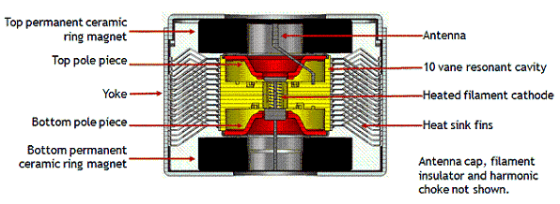A magnetron, as shown in Figure 1, uses resonant magnetic cavities to excite electrons into EM waves. Magnetrons were invented in the 1920s and have significant commercial use in microwave ovens and radar today.

As a result, magnetrons well understood and refined, and relatively inexpensive. The advantages of the magnetron are its low cost and easy availability. According to quotes received, 1000 watt magnetrons are available for as little as $4, while a microwave containing a magnetron and the high-voltage transformer and capacitor necessary to use it costs around $50. However, Magnetrons have several flaws that offset their low cost.

**Figure 1. Magnetron Structure [4]**

Unfortunately, magnetrons have relatively low efficiency compared to other oscillators. An effective magnetron is approximately 75% efficient, while the wasted 25% becomes heat [25]. This excess heat leads to thermal drift, the other major flaw with magnetrons.

Thermal drift in a magnetron occurs when the output frequency of the magnetron changes as the body temperature increases [26]. Thermal drift is typically negative, that is the frequency decreases as the temperature increases. The frequency of the magnetron typically reaches equilibrium after 10 – 30 minutes of operation. Unfortunately, this means that the magnetron will not reach equilibrium during the ort time that the WPT system is activated. This is a problem because the receivers are optimized for a very specific bandwidth and if the frequency drifts outside this range the efficiency falls off drastically.

The oscillator circuit, specifically the Colpitts oscillator as shown in Figure 2, uses capacitors, inductors, and transistors to create an alternating voltage source.

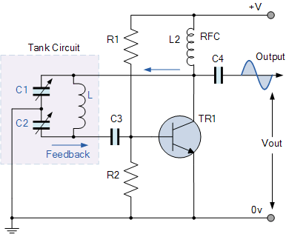

**Figure 2. Colpitt’s Oscillator Circuit Diagram [26]**

The capacitance and inductance in the tank circuit, shown above, determine the oscillating frequency of the circuit according to Eq. 2.

 (2)

The Colpitts oscillator offers several advantages over the magnetron. Specifically, the Colpitts oscillator offers much greater efficiency than the magnetron, up to 90% [27]. The oscillator also has a very stable frequency, avoiding the frequency drift issues. Unfortunately, the oscillator is also much more expensive than the magnetron. According to received quotes, to create an oscillator capable of producing 1000 W, it would cost over 300 dollars in surface mount components and nearly 1000 dollars for a high current, 50Ω circuit board to be fabricated and assembled. These costs would be driven down if mass produced but it would be difficult to match the cost of the magnetron. The choice of which system to use would be a balance between the fixed cost and the cost of electricity.

*Antenna*

The main part of the transmitter subsystem is a high-directivity transmitter, such as a parabolic dish or horn-shaped antenna. Parabolic and other similar antennas have very low losses and very high gains, meaning that for any given input power, the output power density is very high [28]. This is because they focus the output into a small aperture, as opposed to transmitting spherically. This increases the efficiency of the system by focusing all of the emitted waves at the road surface, where the cars can use them, instead of uselessly transmitting waves into the atmosphere. The antenna shape can be further optimized to minimize the non-road area covered by the beam in order to increase the efficiency.

The transmitter would be positioned above a designated lane on the roadway so that the beam would cover the lane underneath it completely. The height would be the same as the minimum height for structures above the roadway, which in the US is 4.9 m [30]. Fortunately, the drop in efficiency is relatively small at the distances which would be used in our design; in fact, in experiments performed by Volvo Technologies efficiencies of 84% at ranges between 2m and 6m were recorded [29]. The implementation for this system would be fairly cheap and quick. The transmitter could be attached to existing road signs, and where needed new frames, similar to those used by road signs, could be emplaced. Each emplacement, not counting the WPT system, would cost between $21000 and $27000 dollars [32]. However this cost is insignificant compared with 100 Billion Dollar MAP-21 Act, which provided grants to improve highways and transit [30].

However, placing the transmitter higher would allow for the coverage of more of the road’s surface. Consequently, the height of the transmitter would have to be optimized for each region by comparing the cost of energy to the cost of the transmitter assembly.

In order to effectively power electric vehicles along a roadway, the lateral spacing of the transmitters must also be considered. The most important factor in placement is to ensure that the vehicles receive enough power. The amount of power absorbed by a vehicle traveling one meter can be calculated using Equation 3, where ρ is the energy density in W/m^2, SA is the surface area of the receiver, V is the velocity in m/s, and ε is the conversion efficiency.

 (3)

In order to simplify the calculation, it is assumed that the vehicle is traveling at a typical freeway speed of 100 km/h. If we design for a power density of 8000 W/m^2, with the average automobile surface area of 5.6 m^2, a velocity of 100 km/h, and a conversion efficiency of 84% (based on the results of past WPT experiments) our vehicle would absorb 1380 J per meter (L = 1m) traveled [31]. Consequently, the energy absorbed per meter is more than sufficient to power a conventional vehicle such as the Tesla Roadster, which requires approximately 400 J per meter [30]. This means that in order to power a modern electric vehicle, only approximately half (including a safety factor of 1.5) of the surface of the road would need to be powered.

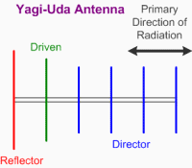The antenna portion of the transmitter system will be designed to operate at a frequency of 2.45 GHz. In this microwave frequency, there are several different types of antennas that would sufficiently transmit the power needed to wirelessly power a moving vehicle. Among these, yagi uda’s, parabolic, and horn antennas were three options that would adhere to our wireless power transmission (WPT) system with the greatest efficiency. All three of these options obtain high directionality and gain. Considering our transmitter system will be positioned to be aimed downward toward the highway, an intensified beam of signal focused on one section of the road will be necessary. Thus, explains our need for a highly directional antenna. Gain measures how focused the beam is. A high gain will allow our beam to be focused mainly on the vehicle during its period of time in the receiving zone. Since each of these antennas maintain high values for gain and directivity, the ease in construction made the yagi uda antenna, as shown in Figure 3, was chosen for our WPT system.

The yagi uda antenna consists of three elements: the driven element, the reflector, and the directors. The driven element powers the antenna and the reflector and directors help to direct and focus the beam to achieve a high gain, typically more than 10 dB [35]. Each element is determined by the wavelength of the EM wave being transmitted. To achieve maximum efficiency the Driven element should be ½ the wavelength, while the reflector should be 55% and the directors 45% of the wavelength and should be spaced approximately 1/6th of the wavelength apart [35].

**Figure 3. Yagi Uda Diagram**

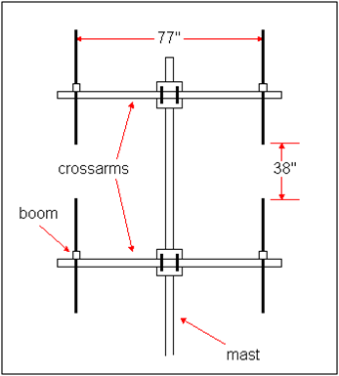The Yagi antennas can then be arranged in a phased array to increase the antenna gain by focusing the beams and reducing dispersion. The phased array, as shown in Figure 4, produces a nearly planar beam of radiation that would be directed downward onto the car and would assure minimal losses over the distance [31].

Several of these arrays can be used to assure total coverage of the roadway. The distribution of the radiation was solved for in a finite difference time domain (FDTD) simulation shown in Figure 5 [31].

**Figure 4. Yagi Uda Phased Array**

Antennas

**Figure 5. Phased Array Radiation Shape & Intensity [31]**

As shown in Figure 5, the phased array ensures that minimal radiation is directed towards areas other than the car. This would minimize the exposure for vehicles in the other lanes and as such, protect them from health risks.

Fortunately, these antennas are fairly inexpensive to assemble. Based on length restrictions of the Yagi antenna due to strict measurement characteristics involving frequency and size, the size of each Yagi Uda antenna would be about 4.5 in x 7.5 in. The small size of the antenna and the flexibility of building means that it is inexpensive to produce. For example, a Yagi Uda antenna designed for the relevant frequency range can be bought for as little as $10. The coaxial cables which connect to the power source must also be considered as they are required to handle high amounts of power at a high frequency. This means that standard coax cables would be ineffective due to increased loss at high frequencies. However, the cost of high frequency cables, approximately $1 per foot, is still insignificant when compared with the overall cost of the system [36].

*Control System*

The third part of the transmitter subsystem is the control system. This control system will detect the presence of a WPT vehicle and turn the transmitter on. This will greatly increase the efficiency of the system and protect pedestrians or unsuitable vehicles from the microwaves.

This efficiency gain is because most of the road surface is uncovered at any given time, meaning that any energy transmitted at that time would be wasted. In fact, at max capacity, as determined by a study performed in the Balkans, a two lane highway can carry around 12,000 cars per day [37]. This means that around .14 cars pass a given point each second. Whereas if the entire road surface were covered by cars traveling at highway speed, there would be about seven cars per second, calculated by dividing the speed traveled by the average length of a car. This means that averaged over a day, at max road capacity, only approximately 1/50th of the road is occupied by vehicles meaning each transmitter would only have to be on about 2% of the time.

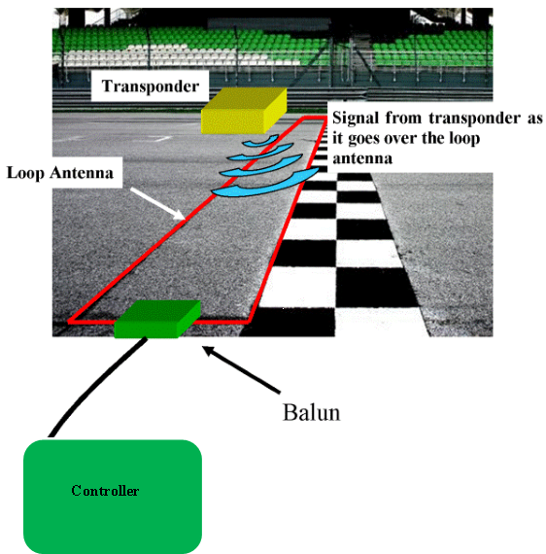

The system will detect WPT vehicles using a system of RFID transponders integrated into the vehicles and the road as depicted in Figure 6. These transponders will send a signal the control system to activate the transmitter

The system will also have some system to detect pedestrians in the path of the beam. This system will consist of a camera and a program to recognize pedestrians. This will ensure that no pedestrians are exposed to the microwave radiation. The transponder and detector systems are fairly inexpensive because they consist solely of off-the-shelf components.

**Vehicle Subsystem**

The vehicle subsystem consists of a rectenna, an auxiliary battery, and a control unit. The rectenna, a circuit consisting of an antenna and rectifier, receives the radio waves from the transmitter and converts them to DC power. The auxiliary battery stores received power so that the vehicle can travel between transmitters, and the control unit manages the flow of power. These subsystems would be designed into new electric vehicles; however, they could also be retrofitted into existing BEVs in place of their normal battery packs.

**Figure 6. Transponder System [38]**

*Rectenna*

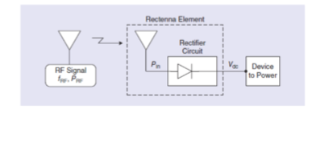The most important consideration in the design of the vehicle subsystem is maximizing the energy received. This is determined by the efficiency of the system and the area of the antenna. As a result, the receiver must maximize its area while remaining efficient. In order to maximize the receiving area the receiver must cover as much of the bodywork as possible. Since a large disc on top of a car would be expensive, heavy, and ugly, the receiver should be incorporated into the existing car as much as possible.

**Figure 7. Rectenna System Diagram [34]**

Consequently, an array of micro rectennas would be most effective. A micro rectenna, as shown in Figure 7, consists of a microstrip antenna connected to a rectifier [39]. The antenna receives the radio waves in the form of high-frequency alternating current. The rectifier, usually a diode, converts this AC power into DC which can be used to charge the battery. Micro rectennas offer several significant advantages that make them ideal for this application. First, they are extremely efficient, able to receive and convert greater than 85% of the power transmitted to them [39]. Secondly, they can be manufactured in a film that can be incorporated into the bodywork of the WPT vehicle [40].

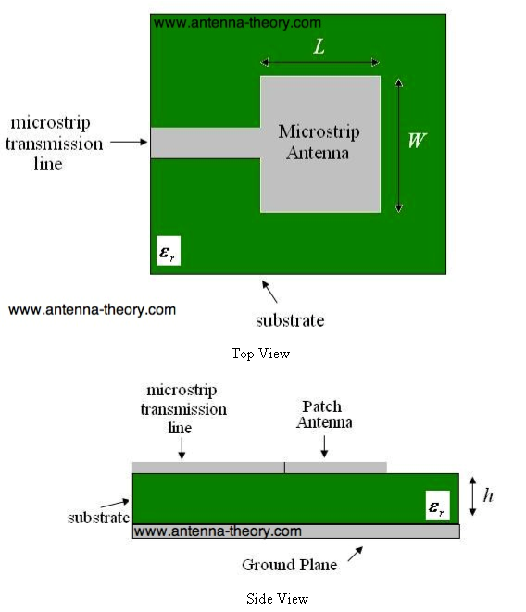A microstrip antenna is a patch of metal separated from a ground plane by a substrate of low permittivity as shown in Figure 8 [23].

The patch is inductively coupled with the ground plane which hare both excited by the incoming radio waves. The size of the patch is determined by Eq. 1. While the ground plane size can be adjusted to modify the receiving frequency of the patch antenna but is typically twice as large. A Microstrip antenna for 2.45 GHz is approximately 25 mm in length and width with twice as large a ground plane. Microstrip antennas are relatively inexpensive, according to quotes received, they are approximately $0.25 per 2W antenna. Approximately 2250 antennas and ground planes could be fit on the entire 5.62 m2 of vehicle surface area. This results in a power capacity of 4500 W, and a cost of $560. The price of the antennas is insignificant compared to the price of the battery pack in a traditional BEV and will be driven down by the economy of scale. However, the power capacity is insufficient to the needs of the car, which will be receiving approximately 44000 W while under the transmitter. This means that the power capacity of the receiver needs to be multiplied by a factor of 10. However, this is relatively easy to achieve, as any readily available antenna is not specifically designed for power transfer, instead it is designed for Wi-Fi transmissions. With a specially designed antenna for power transfer, the target 44000 W is easily achievable.

**Figure 8. Microstrip Antenna Geometry [23]**

This microstrip antenna would be connected to a rectifier to convert the high frequency AC power received by the antenna into usable DC power. This rectifier would be a full-wave rectifier with smoothing such as the one shown in Figure 9 [40]. The rectifier shown uses four diodes to alternatively let the positive current through or reverse the negative current. The smoothing capacitor makes the DC output much cleaner and more efficient. Rectifiers such as this are very efficient, achieving greater than 90% efficiency at microwave 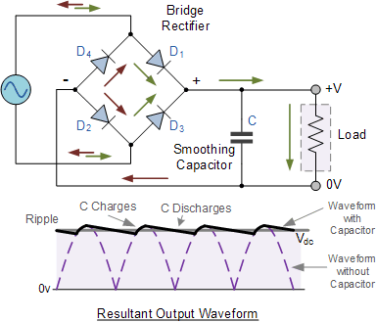range frequencies [40]. This rectifier design is also very inexpensive, costing according to quotes received approximately $ 2.5 per 45W rectifier. This means that 1000 rectifier circuits would be needed for the WPT vehicle, costing $2500 which is still insignificant compared to the cost of a battery for a traditional BEV. The cost and power capacity could be improved with more development.

*Battery*

The battery is an important part of the system because it allows the vehicle to travel between transmitters and also allows for the possibility of travel in an area without transmitters. According to the National Household Travel Survey the average commute to work for an American household is around 12.2 miles [42]. By Equation 4, in which D is distance traveled in miles, E is joules required per meter, and C is required battery capacity, including a factor of safety of 1.5, a 5.5 kW-h battery would be required to commute to work without any WPT.

**Figure 9. Full-Wave Rectifier [41].**

 (4)

This battery would also help regulate the power received by the motor instead of relying solely on WPT which could be affected by the weather and other environmental factors. This battery would be a Lithium-Ion battery, similar to the batteries used in every major BEV. However this battery would be much smaller and so would cost much less, approximately $2200 dollars, instead of $34000 and would also weigh much less [13].

The Battery and motor of the car would be paired with an electronic control unit (ECU) that would distribute power to the motor and the rest of the car. This ECU would also control when the battery is charging and would allow the vehicle to utilize regenerative braking and other techniques to increase efficiency. This ECU would be fairly similar to that found in a typical BEV and so would not increase the cost or weight significantly.

**Designing For City Driving**

The proposed WPT design is optimized for implementation on highway roads, an area where car movement is steady and pedestrians are rare, implementation in a city environment creates new issues and magnifies several existing ones. In a city cars move much slower and less smoothly, use more energy, and interact much more with pedestrians. This means that the WPT must be optimized to protect pedestrians in a city.

In order to protect citizens in a city the energy density of the EM wave must be within safe exposure limits, 80 W/m2. Even, so the amount of pedestrian exposure must still be limited so the pedestrian detection system and transponder system would still be in effect. Fortunately, because of the slow city speed the vehicles will be able to absorb more energy per meter of travel than it would at highway speed. Assuming a city speed of 15 m/s with an 80 W/m2 power density and using Eq. 3. The vehicle will absorb 25 J per meter of travel. Unfortunately, this is not nearly enough to power the vehicle continuously. However, the WPT vehicle still has 30 mile range on its battery and can be charged as a BEV which is more than enough for the average city commute of 12.2 miles.

Ultimately, WPT is not cost effective in a city situation but remains viable on open roads such as highways or suburban and rural roads unless a new method is developed to shield pedestrians from the radiation.

**Safety Analysis**

The safety of the people involved in the use of the WPT system, be they in the WPT vehicle, fellow drivers, or pedestrians must be paramount. This means that no person can be exposed to radiation above the IEEE exposure limit. Fortunately, the WPT system has safeguards built in to prevent such exposure.

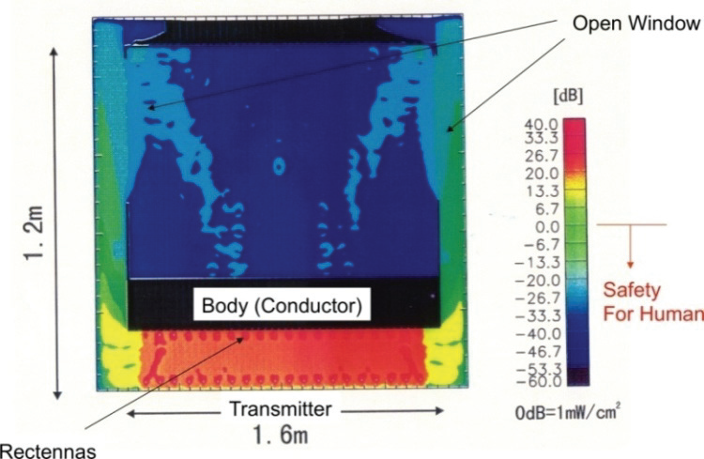Firstly, the WPT controller has a system built in to detect if a pedestrian is in the path of the radiation and will not turn on if so. Secondly, The WPT system would be implemented with special WPT only lanes so that other vehicles would be less likely to be exposed to radiation. Thirdly, modern automobiles shield their occupants from microwave radiation because the metal body reflects microwave radiation and acts as a faraday cage for the currents generated, as proven in the FDTD simulation shown in Figure 10 [44], [32]. Fourthly, the WPT system would install transponders in WPT capable vehicles would be the only vehicles to activate the transmitters. This will ensure that vehicles that did not fully shield their occupants from radiation, such as convertibles with open tops or motorcycles, will not be exposed to radiation.

**Figure 10. FDTD Simulation of Car in Microwave Beam [32]**

**Environmental Analysis**

Changing from IC vehicles/BEVs to WPT vehicles would significantly reduce our total GHG emissions. The U.S. Department of Energy currently estimates the total GHG emitted by the burning of gasoline in highway vehicles every year to be 1.5 billion metric tons [3], whereas WPT vehicles would produce no GHGs if all of the electricity used to power them came from non-polluting sources such as wind or solar power. Even if clean energy sources were not used, the WPT vehicle would still result in less GHG emission. In fact, fully energizing the European Union’s road network would require approximately three fourths of the energy all of the vehicles in the E.U. currently use. The E.U.’s road network has a surface area of approximately 4.04 trillion square meters [45]. This means that it would require 32 TW (8000 W/m^2 multiplied by the surface area) to provide continuous power to the road surface. However, only half of the road surface would be powered, and that power would be supplied for only approximately 1/50th of the time. Consequently, the total power required would be only 320 GW, which over the course of a year would be 9.8 million TJ or approximately 240 megatons of oil equivalent. This is only 65% of the 370 megatons of oil equivalent currently used for transportation in the E.U. [46]. Finally, needing only a smaller back-up battery in the vehicle decreases the amount of GHGs emitted during battery manufacture. All reductions due to the switch to WPT vehicles would move the population closer to the goal of 0 and negative net GHGs released annually into the atmosphere. The reduction would mitigate the effects of climate change and lead to an overall healthier atmosphere.

Switching from BEV models to WPT power would also reduce the toxins allowed into the environment from improper battery disposal. Used batteries often end up in landfills to decompose. Here the toxic metals that they are made of are released into the environment. Smaller WPT batteries disposed of in this way would lead to smaller traces of toxins and a healthier environment.

**Cost Analysis**

Currently, cost is a major hurdle for the introduction of the electric vehicle. The WPT vehicle aims to reduce the major cost in a BEV, the battery. Currently, the battery in an electric vehicle such as the Model S makes up a huge proportion of its total cost. In the case of the Tesla Model S the battery, if manufactured at current $400 per kw/h costs, is approximately $34000 which is greater than 1/3rd the total cost [13].

The cost to the consumer of the WPT is made up of two parts: the extra cost of the WPT system on the car and the cost of the energy to power the car. The cost of the WPT system takes into account the battery, the receivers, and the rectifiers. The battery costs approximately $2200, the rectifiers cost approximately $2500, and the receivers cost (assuming that mass production is able to keep the cost at current levels) $560. Assuming a factor of safety of 1.5 for production costs and mounting and wiring, that brings the cost for the WPT system to $7900 which is less than 1/4th the cost of the battery for the BEV. To put that into perspective, one could buy a whole entry level car with the money saved from using the WPT system.

The indirect cost of the WPT system comes in the energy cost to power the vehicle. I’m going to assume for simplicity, that everyone in the world owns a WPT vehicle and all pay a flat tax to the government to pay for the energy usage. This also assumes that the initial implementation costs are paid for by the government, like with MAP-21, or private corporations. This tax will be based upon current energy costs. A WPT vehicle would use more energy to travel because the Wireless Power transfer has losses inherent in it. The WPT vehicle would be 84% as efficient as a BEV with the same drivetrain and physical properties. However, the WPT would weigh significantly less than the BEV and would consequently gain some of the efficiency back. Based on current electricity costs driving a BEV 15,000 miles a year about $600 [4].The corresponding WPT vehicle would cost $715 dollars a year. However, driving the WPT vehicle is approximately $1200 cheaper than driving an internal combustion engine vehicle (assuming $3.54 per gallon and a 28 miles per gallon). This alone results in a 63% reduction in fueling costs.

**Description and Analysis of Our Mock-Up**

The mockup consisted of the same subsystems as the proposed design: Transmitter and vehicle.

**Transmitter Subsystem**

*Wave Generator*

Due to budget constraints, we constructed our wave generator from repurposed microwave oven parts, as we believed that they would be able to provide a reasonable energy supply/wave transmission.The microwave oven’s power supply unit (PSU) is directly plugged into a standard wall outlet (which provides 120 Volts in the United States). The PSU serves to regulate the power received from the wall outlet and suppress power surges, and it also serves as a ground for the wave generator’s circuit. The PSU is wired to a power relay, which serves as a switch to activate or deactivate the circuit. The power relay is connected to a transformer, which connects in parallel to a capacitor and a magnetron. The transformer increases the 120 Volts to the 10000 Volts at which the magnetron operates, and the magnetron is the element of the circuit that produces the oscillating current responsible for the generation of the microwaves. The magnetron is attached to a waveguide, which directs the current into a coaxial cable and eventually into the antenna system.

The power source was a major problem in the construction of the mock-up, and its failure to function was ultimately the factor which prevented our team from testing or obtaining any data from our mock-up. This power source is theoretically capable of outputting 1000 Watts of power, but we could not get the system to produce a significant amount of power, and it became clear that the repurposed microwave oven parts are insufficient for use as a power source. However, budget and time constraints prevented us from obtaining more effective parts in order to conduct a test of our system.

An alternate wave generator will be employed in future developments, as the one we constructed proved ineffective. A search will be conducted for an another option, which will need to produce a significant amount of power for a reasonable cost.

*Antenna*

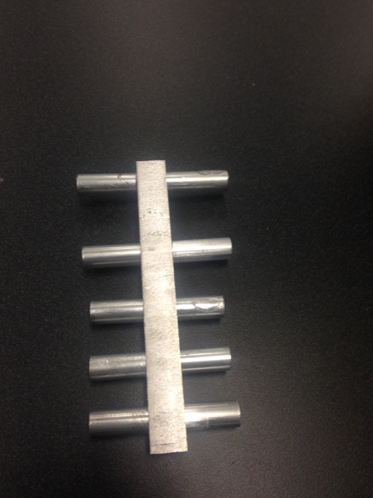Our antenna system is comprised of four self-made Yagi Uda antennae assembled into a phased array system. These antennae are ideal due to their high directivity, gain, efficiency, and simplicity in construction. The phased array system allows four identical antennae to be arranged in such a way that the overall gain is maximized, the interference between antennae is minimized, and the transmitted power is intensely focused in a specified direction.

Each 5-element Yagi Uda antenna consists of one reflector, one driven element, three directors, a boom which holds together the elements, and a gamma matching system connected to the driven element. Figure 3 to the left shows one of the 5-element Yagi Uda antenna without the gamma matching system**.** The standard Yagi Uda antenna is a three-element antenna, meaning 1 reflector, one driven element, and one director. Increasing the amount of elements increases the gain in the antenna. Typically, the first director adds approximately 3 dB of overall gain, the second adds about 2 dB, the third adds about 1.5 dB, and the gain added per director continues to decrease as the number of directors increases [1]. Adding additional directors always increases the gain, but directivity decreases as the number of elements gets larger. It was determined that a 5-element Yagi Uda would optimally demonstrate feasibility while also staying within budget limits.

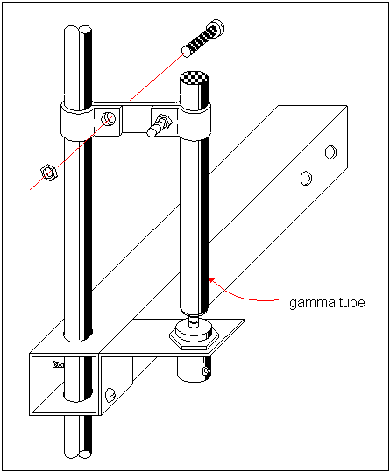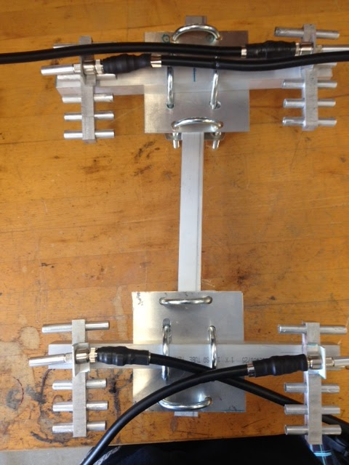Standard Yagi Uda dimensions dictate that the reflectors should be about 5% longer than the driven elements, the driven elements should be about 5% longer than the directors, and all directors should be the same length [1]. Larger reflectors are better physical reflectors, and if the reflector is longer than its resonant length, the impedance of the reflector will be inductive [2]. The director elements are shorter than their respective resonant length, making them capacitive, so that their current leads the voltage [2]. These reflectors and directors serve as a couple to the transmitter power through local electromagnetic fields which in turn induces a current within them. The driven element is the only element which is actually excited through a source voltage or current. There are many ways to construct the driven element of a Yagi Uda antenna. Our design is a half wave dipole with a capability to be fine-tuned.

The tuning of the antennae is accomplished with a gamma matching system connected near the center of the driven element. The gamma matching system allows the transmission line to be connected near the center of the continuous half wave conductor and tap it to the point of most efficient power transfer. *Figure 4* to the left gives a simplified example of the driven element/gamma system in which we incorporated

.

The middle of the halfwave dipole is electrically neutral, meaning there is no RF voltage present. Because of this, the outer conductor of our LMR 400 coaxial cable can be connected directly to the element at this point. The inner conductor of the coaxial cable carries an RF current so it has the capability of being tapped into the dipole element at the gamma matching point. The center conductor of the coaxial cable is not directly connected to the driven element, but instead is coupled via a gamma tube, an aluminum tube that covers a short piece of LMR 400 cable. The combination of the short gamma tube and the coaxial cable inside provides the capacitance needed to cancel the inductance of the driven element and attain an electrical balance. Thus, the functions of the gamma match include matching the impedance of the transmission line to the impedance of the antenna and to couple the unbalanced coaxial cable to the symmetrical dipole element. Fine tuning these four antennae is achieved by adjusting a shorting bar that connects the gamma tube to the dipole driven element until the lowest SWR is achieved.

Implementing these four antennae into an array causes greater efficiency in wireless power transmission. Once our initial array was set up, we connected each antenna through a set of coaxial cables. The cables were soldered together to form T connections which allowed all four antennae to ultimately be connected to one cable. *Figure 5* on the previous *page* shows the connection of the cables to the antennae in the phased array. With a frequency of about 2.45 GHz, the elements of each antenna came out to be very short.

|  |
| --- |
|  |

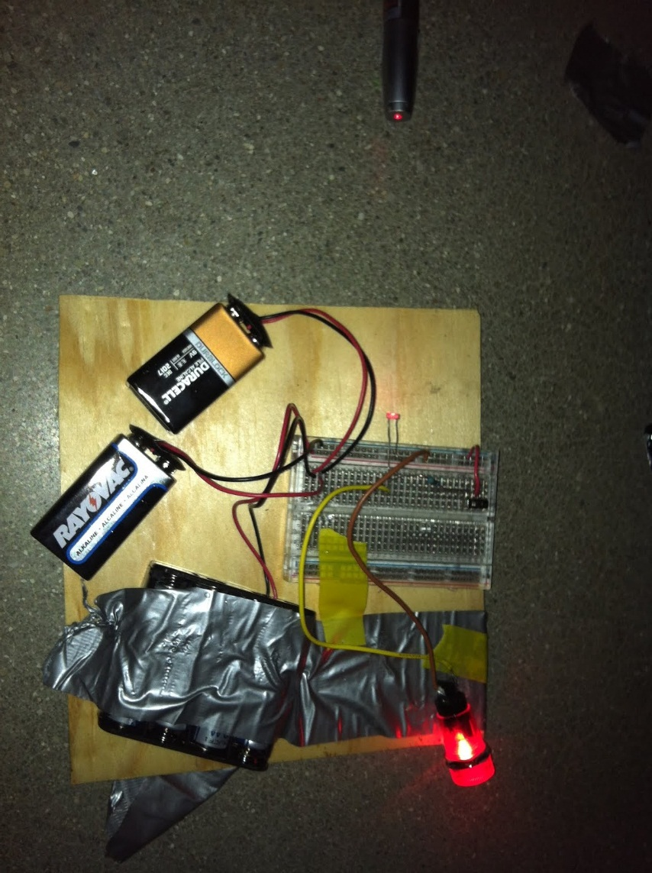

*Control System*

The RFID system intended to be included on the full-scale transmitter is impractical to include in our mock-up, due to scale and budget constraints. For this reason, a laser tripwire system (as shown in Figure 7) was substituted as the vehicle detection system. This system is centered around a photoresistor and a laser pointer. The photoresistor is wired to a voltage source comprised of several batteries, and the photoresistor, another resistor, and the output wire of the laser tripwire system are wired in parallel, creating a voltage divider. When the laser is shining on the photoresistor, the photoresistor’s resistance drops to approximately the same resistance as the other resistor. When the laser’s beam is interrupted (when the system is “tripped”), and the photoresistor is exposed to ambient light, the resistance increases tenfold. As a result, the voltage passing into the output wire increases. The output wire is connected to the relay in the power source circuit.

By varying the total voltage of the batteries in the vehicle detection system circuit, the voltage passed into the relay was calibrated so that it exceeds the activation voltage of the relay when the laser shines on the photoresistor, and does not exceed the activation voltage when the laser’s beam is interrupted. Because of this, the power source circuit is opened when the laser shines on the photoresistor, and is closed when it ceases to shine on the photoresistor. The laser is set up along the intended path of the vehicle, so that the vehicle interrupts the laser and trips the system as it drives under the transmitter antenna array, turning on the power source and causing it to transmit power exactly when the vehicle is in the optimal position to receive it.

The Vehicle Detection system works perfectly. While it does not have all of the capabilities of the RFID system intended to be used in the full-scale system, it serves its purpose without fail.

**Vehicle Subsystem**

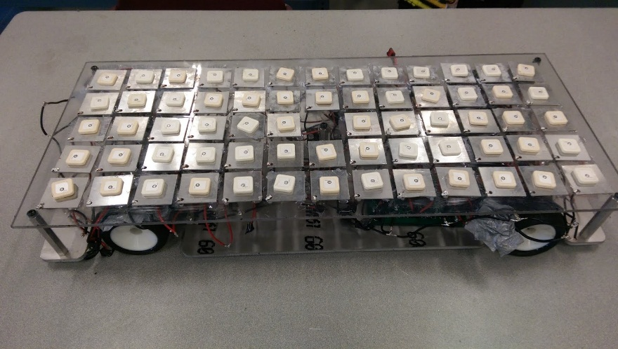Our prototype car is designed to be a 1/5th-scale version of a wirelessly powered electric vehicle. It contains all of the same major systems as a full-scale wirelessly powered electric vehicle, including the patch antenna array, rectifier, current limiting circuit, auxiliary battery, ECU and DC motor.

In our mock-up, the antennae are designed to pick up the 2.45 GHz microwave energy being emitted by the transmitter. The antenna receive the energy in the form of high frequency AC which is then converted to a DC current by the rectifier. The antenna are arrayed 5 wide and 13 deep resulting in 64 total antennae. Each antenna can withstand 2 watts of power. This means that the rectifier is supplied with approximately 128 watts of power. This results in approximately 60 V.

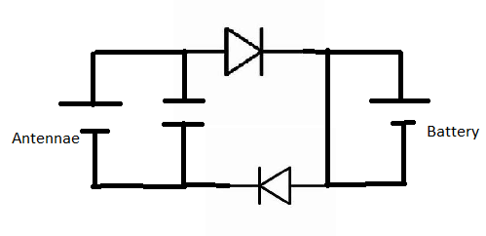The current limiting circuit (displayed in Figure 9) then smooths any spikes in this current, protecting the battery from damaging spikes in power. The current limiting circuit employs a capacitor and two diodes to allow for gradual increases in power, and prevent dangerous spikes while charging the battery.

The auxiliary battery stores the power received by the antennae and provides it to the motor. The vehicle mock-up would then perform tests to determine how much energy it was absorbing and the efficacy of the tripwire system. The tests which we intended to perform but were unable to due to problems with the wave generator included a stationary test of the transmitter and receiver subsystems, a test displaying the vehicle driving using the power received from the transmitter, and a test analyzing the strength of the radiation produced by the transmitter while inside a vehicle (measured using a spectrum analyzer).

**How we would present**

Should we belong to the top 6 finalists allowed to present their Innovation to the Grand Jury in Paris, our plan is to explain the current issue and solution to it to the jury while using pictures and video of the physical mockup to demonstrate our concept. We would start by presenting the problem and the potential impact it has on our world. We would then present the current solutions and why they fall short of solving the issue. We would then give a detailed presentation of our system and the theory behind it. We would then showcase our mock-up design. This would include displaying the receiving antennae circuit and rectifier, the battery, the RFID trigger system, and the ECU. Finally, we would show a video of our testing with the mock-up system to present our results. We would not activate our prototype as it is too dangerous to bystanders. We would discuss the pluses and minuses of our solution, and how we intend to further improve the system.

For our presentation we would need to have access to a projector or a screen that we could show our presentation, pictures, and videos on. We would also need to ship our prototype vehicle and transmitter from Terre Haute, IN to Paris.

**Works Cited**

[1] [*Years of Fossil Fuel Remaining.* Chart. BP, 2011. http://www.energyrealities.org/chapter/energys-future/item/years-of-fossil-fuels-remaining/erp6D28994FAAEECC86A](http://www.energyrealities.org/chapter/energys-future/item/years-of-fossil-fuels-remaining/erp6D28994FAAEECC86A)

[2] W. L. Hare. (2009). “A Safe Landing for the Climate - the 1C Target.” *Worldwatch State of the World.* [Online]. Available:<http://onlyzerocarbon.org/uploads/Hare_state_world.pdf>

[3] U. S. Department of Energy. (2013). “Reduce Climate Change” *Fueleconomy.gov* [Online]. Available:<http://www.fueleconomy.gov/feg/climate.shtml>

[4] D. Gordon and D. Sperling. (2009). “Surviving Two Billion Cars: China Must Lead the Way.” *Yale Environment 360.* [Online]. Available:<http://e360.yale.edu/content/feature.msp?id=2128>

[5] [“GHG Emissions.” (2014). *Oil Sands Today.* [Online]. Available: http://www.oilsandstoday.ca/topics/ghgemissions/Pages/default.aspx](http://www.oilsandstoday.ca/topics/ghgemissions/Pages/default.aspx)

[6] [U.S. Environmental Protection Agency](http://epa.gov/climatechange/ghgemissions/gases/ch4.html)[, *Methane and Nitrous Oxide Emissions from Natural Sources*](http://www.epa.gov/outreach/pdfs/Methane-and-Nitrous-Oxide-Emissions-From-Natural-Sources.pdf)[. Washington, DC, USA: GPO, 2010.](http://epa.gov/climatechange/ghgemissions/gases/ch4.html)

[7] T. Stevens. (2011). “Tesla Roadster 2.5 Sport Review.” *EnGadget.*  [Online]. Available:<http://www.engadget.com/2011/04/01/tesla-roadster-2-5-sport-review/>

[8] “Economics of Renewable Energy Plants.” (2013). *Green Rhino Energy.* [Online]. Available: <http://www.greenrhinoenergy.com/renewable/context/economics.php>

[9] C.R. Malavika. (2004, Jul. 14). “Environmental Effects Associated with Battery Disposal,” *Frost & Sullivan.* [Online]. Available: <https://www.frost.com>.

[10[] J. Conca. (2013, July 21). “Are Electric Cars Really that Polluting?” *Forbes,* [Online]. Available: http://www.forbes.com/sites/jame](http://epa.gov/climatechange/ghgemissions/gases/ch4.html)[sconca/2013/07/21/are-electric-cars-really-that-polluting/](http://www.forbes.com/sites/jamesconca/2013/07/21/are-electric-cars-really-that-polluting/)

[11] [A. Kardile. (2011, Apr 11). “10 Quick Facts from the 1973-74 ‘Oil Shock.’”*League of extraordinary Value Investors.* [Online]. Available: http://valueinvestorsleague.blogspot.](http://valueinvestorsleague.blogspot.com/2011/04/10-quick-facts-from-1973-74-oil-shock.html)[c](http://www.maisonthenezay.fr/Maintenance_HF/NAB_files/2-01.PDF)[om/2011/04/10-quick-facts-from-1973-74-oil-shoc](http://valueinvestorsleague.blogspot.com/2011/04/10-quick-facts-from-1973-74-oil-shock.html)[k](http://www.engadget.com/2011/04/01/tesla-roadster-2-5-sport-review/)[.html](http://valueinvestorsleague.blogspot.com/2011/04/10-quick-facts-from-1973-74-oil-shock.html)

[12] [K. Amadeo. (2014, Apr. 24). “Crude Oil Prices: Definition.” *about news.* [Online]. Available: http://usec](http://useconomy.about.com/od/economicindicators/p/Crude_Oil.htm)[onomy.about.com/od/economicindicators/p/Crude_Oil.htm](http://www.maisonthenezay.fr/Maintenance_HF/NAB_files/2-01.PDF)

[13] M. Rogowsky. (2013). “Tesla’s 1% Problem Isn’t What You Think.” *Forbes Magazine.* [Online]. Available:<http://www.forbes.com/sites/markrogowsky/2013/11/06/teslas-big-earnings-news-nothing-can-rid-the-world-of-gas-powered-cars-very-quickly-but-its-going-to-try/>

[14] “The Price of Batteries: Although costs are uncertain, they will be key to the success of electric cars.” (2010). *Technology Review*. [Online]. Available: <http://www.technologyreview.com>

[15] J. J. Bakker. (2011, May). “Contesting range anxiety: The role of electric vehicle charging infrastructure in the transportation transition,” *TU/e.* [Online]. Available: <http://alexandria.tue.nl>.

[16] S. Patterson. (2013, Oct. 2). “Electric Car Charging Stations Now Numbering 64,000.” *WebProNews.* [Online]. Available: <http://www.webpronews.com/electric-car-charging-stations-now-number-64000-worldwide-2013-10>

[[17](http://valueinvestorsleague.blogspot.com/2011/04/10-quick-facts-from-1973-74-oil-shock.html)] *Car Stations.* Map. World: Electric Car Stations, 2011.<http://carstations.com/>

[18] “Generic Cost Per Mile Models.” *Capitol Fax*. [Online] Available: <http://capitolfax.com/summary.pdf>

[19] RP Siegel. (2012, May 10). “Fuel Cell Energy: Pros and Cons.” *Triple Pundit.* [Online]. Available: <http://www.triplepundit.com/2012/05/fuel-cell-energy-pros-cons/>

[20] J. Voelcker. (2014, Feb. 4). “Hyundai On Hydrogen Fuel-Cell Vehicles: Critiquing Its Claims.” *Green Car Reports.* [Online]. Available: <http://www.greencarreports.com/news/1089569_hyundai-on-hydrogen-fuel-cell-vehicles-critiquing-its-claims>

[21] *Hydrogen Fueling Station Locations.* Map. The United States:U.S. Department of Energy, 2012.

[22] R. Dickinson and O. Maynard. (1999). “GROUND BASED WIRELESS AND WIRED POWER TRANSMISSION COST COMPARISON”. *Jet Propulsion Laboratory*. [Online]. Available:<http://trs-new.jpl.nasa.gov/dspace/bitstream/2014/17841/1/99-1291.pdf>

[23] Antenna-theory.com. (2011). “Microstrip Patch Antenna”. *Antenna-theory.com.* [Online]. Available:<http://www.antenna-theory.com/antennas/patches/antenna.php>

[24] Chemical and General Safety Department. (2008). “Non-ionizing Radiation: Selected Radio Frequency Exposure Limits.” *SLAC National Accelerator Laboratory.* [Online]. Available:<http://www-group.slac.stanford.edu/esh/eshmanual/references/nirreqexplimits.pdf>

[25] Computer Simulation Technology. “Magnetron and Microwave Oven Design to Solve Wi-Fi - Interference Issues.” *CST AG.* [Online]. Available:<https://www.cst.com/Applications/Article/Magnetron+and+Microwave+Oven+Design+to+Solve+Wi-Fi+-+Interference+Issues>

[26] Beverly Microwave Division. “Magnetrons.” *Communications & Power Industries.* [Online]. Available:<http://www.cpii.com/docs/related/2/Mag%20tech%20art.pdf>

[27 W. Storr, (2014) “The Colpitts Oscillator.” *Electronics Tutorials.* [Online]. Available:<http://www.electronics-tutorials.ws/oscillator/colpitts.html>

[28] S K. Bhattacharya, S Chatterjee, and T Chandigarh, *Industrial Electronics and Control,* Tata McGraw-Hill Education, 1998, Pg 380.

[29] M. Barringer. “Radio Wave Propagation.” *National Association of Broadcasters.* [Online]. Available[: http://www.maisonthenezay.fr/Maintenance_HF/NAB_files/2-01.PDF](http://www.maisonthenezay.fr/Maintenance_HF/NAB_files/2-01.PDF)

[30] AASHTO. (2001) “A Policy on Geometric Design of Highways and Streets.” *American Association of State Highway and Transportation Officials*. [Online]. Pg. 510 Available:<https://law.resource.org/pub/us/cfr/ibr/001/aashto.green.2001.pdf#page=556>

[31] N. Shinohara, *Wireless Power Transfer via Radiowaves,* Hoboken, NJ, John Wiley & Sons Inc., 2014. Pgs. 174 – 177.

[32] R. Mouer, (2014). “Costs of Traffic Signs.” *Manual of Traffic Signs.* [Online]. Available:<http://www.trafficsign.us/signcost.html>

[[](http://www.trafficsign.us/signcost.html)33] ARTBA (2014) “Transportation FAQs” *American Road & Transportation Builders Association.* [Online]. Available:<http://www.artba.org/about/transportation-faqs/>

[34] E. Musk. (2006) “The Secret Tesla Motors Master Plan (just between you and me)”. *Tesla Motors.* [Online]. Available:<http://www.teslamotors.com/blog/secret-tesla-motors-master-plan-just-between-you-and-me>

[35] “Yagi-Uda Antenna.” The Antenna Theory. Online. Available: http://www.antenna-theory.com.

[36] Universal Radio, (2014) “Coax Cable Price List” *Universal Radio.* [Online]. Available:<http://www.universal-radio.com/catalog/cable/coax.html>

[37] L. Berger, (2000) “Appendix 5: Highway Capacity.” *Transport Infrastructure Regional Study (TIRS) in the Balkans.* [Online]. Available:<http://www.internationaltransportforum.org/IntOrg/ecmt/southeast/TIRS/TIRSann05.pdf>

[38] Westhold Corporation. (2013). “Timing Systems.” *Westhold Corp.* [Online]. Available:<http://www.westhold.com/products_timing.html>

[39] A. Boaventura, A. Collado, N. B. Carvalho, and A. Georgiadis. “Optimum Behavior,” *Microwave Magazine, IEEE*. pp. 26-35. March/Apr. 2013.

[40] R. Yadav, S. Das, R. L. Yadava. (2011) “Rectennas Design, Development, and Applications.” *International Journal of Engineering Science and Technology.* [Online]. Available:<http://www.ijest.info/docs/IJEST11-03-10-197.pdf>

[41] W. Storr, (2014) “The Full-Wave Rectifier” *Electronics Tutorials.* [Online]. Available:<http://www.electronics-tutorials.ws/diode/diode_6.html>

[42] Federal Highway Administration (2009). “National Household Travel Survey.” *U.S. Department of Transportation.* [Online]. Available:<http://nhts.ornl.gov/2009/pub/stt.pdf>

[43] J. Loiseau (2013). “Pump vs. Plug: Do You Really Save Money Driving an Electric Car?” *DailyFinance.* [Online] Available:<http://www.dailyfinance.com/2013/06/24/gas-vs-electric-cars-cost-comparison/>

[44] C Ross. (2010) “Why Can’t We Put Metal Objects in a Microwave?” *MIT Ask an Engineer.* [Online]. Available: https://engineering.mit.edu/ask/why-can%E2%80%99t-we-put-metal-objects-microwave

[45] NationMaster.com “[Transportation Statistics](http://www.nationmaster.com/cat/tra-transportation) > Road network surface area > km squared (most recent) by country.” (2013). *NationMaster.com.* [Online]. Available:<http://www.nationmaster.com/graph/tra_roa_net_sur_are_km_squ-network-surface-area-km-squared>

[46] European Commission. “Final energy consumption, by sector.” (2011) *Eurostat.com.* [Online] Available: [http://epp.eurostat.ec.europa.eu/](http://epp.eurostat.ec.europa.eu/tgm/refreshTableAction.do;jsessionid=9ea7d07e30e80c4e081557144378b0f1c02c93784533.e34OaN8Pc3mMc40Lc3aMaNyTb3uLe0?tab=table&plugin=1&pcode=tsdpc320&language=en)